Wind Turbine Airfoil Analysis Using Xfoil Through Python Programming

Ashley Ruth Glass

In order to perform an analysis in Xfoil on the airfoil NACA 63(3)-618, I created a program in python to run Xfoil, collect the data, and graph the results for analysis. This tool performs an analysis with Xfoil at Reynolds numbers of 3 million, 10 million, and 15 million. It also allows the user to choose the airfoil file to be used in the analysis so that comparisons between airfoils can be made. The results of my analysis on this airfoil are provide below.

Figure 1: The coefficient of lift at different Reynolds numbers plotted against the angle of attack

Upon examining the coefficient of lift based on the angle of attack (AoA), it can be seen in Fig. (1) that the lift produced by this cross section of the airfoil continues to increase with a higher AoA. It should also be noted that the airfoil would experience similar lift from wind with a Reynolds number of either 10 million or 15 million. There is a significantly smaller drop in the coefficient of lift for those two Reynolds numbers compared to the drop between the 10 million Reynolds number and the 3 million Reynolds number. In Fig. (2) the similarities can also be seen in the coefficient of drag. This suggests significant increases in lift applied to the airfoil when wind passing the turbine blade exceeds Reynolds numbers of 3 million and AoAs greater than 5 degrees are used.

In order to design a wind turbine with high efficiency, it is useful to examine the lift to drag ratio at various AoAs. This can be seen in Fig. (3). It is clear that the highest efficiency can be achieved at a low AoA when the wind crossing the turbine has a Reynolds number of 3 million. This makes it likely that a low AoA would be most efficient in such conditions to extract energy from the wind. As the Reynolds number of the wind increases, a slightly more aggressive AoA should be used to enable the maximum efficiency for the wind conditions.

Figure 2: The coefficient of drag at different Reynolds numbers plotted against the AoA

Figure 3: The ratio of the coefficients of lift and drag at different Reynolds numbers compared to AoA

The tool I created also gathered information on the boundary layer of the airfoil at the trailing edge. In Fig. (5) the displacement thickness of the airfoil can be seen in relation to the AoA. It can be seen from the Xfoil analysis that the displacement thickness increases rapidly as the AoA increases. The same is true for the momentum thickness, which can be seen in Fig. (6). This means that as the AoA increases there is a higher chance of undesirable flow over the airfoil, such as flow separation, or turbulence causing drag. This relationship between the AoA and flow is further demonstrated in Fig. (7), which shows the shape factor sharply increasing with AoA.

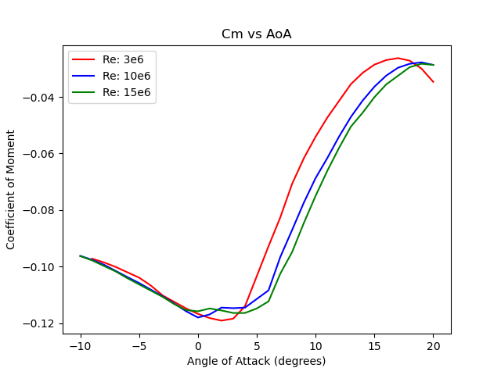Figure 4: The coefficient of moment at different Reynolds numbers plotted against AoA

Figure 5: The displacement thickness at the trailing edge at different Reynolds numbers plotted against AoA

Figure 6: The momentum thickness at the trailing at different Reynolds numbers plotted against the AoA

Figure 7: The shape factor at the trailing edge at different Reynolds numbers plotted against the AoA

In Figures 8, 9, and 10 the coefficient of pressure along the cross section can be seen. Each figure displays four AoAs at a single Reynolds number. This allows a comparison to be easily made between different angles of attack for a given with condition. Comparing these graphs, it can be seen that an aggressive AoA creates a large pressure differential at the leading edge. It can also be seen that the pressure difference on the leading edge increases with an increasing Reynolds number for AoAs of 8 and 12 degrees. For instance, the leading edge in wind with a Reynolds number of 3 million reaches a minimum of approximately -4 for an AoA of 12 degrees, while the wind with Reynolds numbers of 10 and 15 million reach nearly -5.

It is also worth noting the continued trend between wind with a Reynolds number of 10 million and one of 15 million. In all of the plots provided in this analysis the results are incredibly similar for this airfoil at these two Reynolds numbers. This suggests diminishing returns on the efficiency and power generated by higher Reynolds numbers.

Figure 8: The coefficient of pressure along the airfoil cross section at different AoAs with a Reynolds number of 3 million

Considering differing wind patterns that a turbine may encounter it is vital to understand the flow of air across airfoils. This analysis shows python tools combined with Xfoil can be used to optimize the design process of airfoil cross sections.

Figure 9: The coefficient of pressure along the airfoil cross section at different AoAs with a Reynolds number of 10 million

Figure 10: The coefficient of pressure along the airfoil cross section at different AoAs with a Reynolds number of 15 million